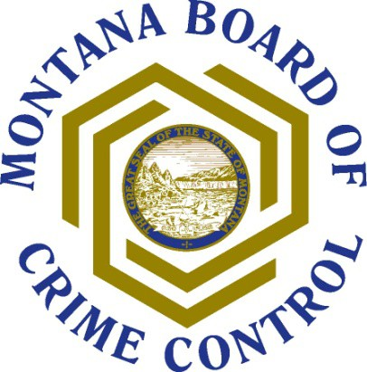

Introduction to Logic Models

What and Whys of Logic Models

What is a Logic Model?
A logic model is an outcomes-based approach to program planning and evaluation. It is a logical and visual way to present the relationships among the resources you have to operate your program, the activities you plan, and the changes or results you hope to achieve. It provides a roadmap from your identified need to your planned work, and finally to your
intended results.

Why Should you Develop a Logic Model?
Logic models provide stakeholders (e.g. program staff, funders, partners, community members and program participants) with a common understanding and language. It can help to communicate a complex program to external stakeholders, and at the same time bring detail to an organization or programs’ broad goals. Your logic model clarifies the difference between activities – what you do – and outcomes – the impact you have. Finally, it creates a chain of reasoning from resources through outcomes that you can use to test assumptions and inform your evaluation.

Resources

W.K. Kellogg Foundation www.wkkf.org/
The Kellogg Foundation has a wide range of useful resources for evaluation and programming. Downloadable resources include English and Spanish versions of a Logic Model Development Guide and an Evaluation Handbook, which provides a framework for thinking about evaluation as a relevant and useful program tool.

Harvard Family Resource Project www.gse.harvard.edu/hfrp/projects/afterschool/resources/learning_logic_models.html takes you to a downloadable brief on logic models and how to construct them.

The Context and Situation
Environment (What you know): A description of your target population, including the demographics, geography, community needs, assets and challenges.
Assumptions (What you think): A description of best practices or research, or other influencing factors that may help of hinder your program.

What you Know What You Think
Your environment, target population, challenges, Your assumptions, best practices or research, community needs, and assets influencing factors that can help or hinder

The Planned Work
Inputs: the human, financial, organizational, and community resources a program has available to direct toward the work.

Activities: what the program does with the resources. The activities, services, tools, events, and products that are an intentional part of the program.

Outputs: the direct product of the activities, i.e. the types, levels and target service numbers.

Inputs | Activities | Outputs
Resources you invest, e.g. funding, personnel, in-kind,  partners | What activities, services, supports or products you offer & how often | Who you serve, numbers and level of participation

The Intended Results
Short and Long-Term Outcomes: the specific changes in program participants’ behavior, knowledge, skills, status or level of functioning that are affected by the program activities. Outcomes are grouped into short term (1-3 years) and long-term (4-6 years).

Impact Outcomes: impact outcomes (7-10 years) are fundamental changes occurring in organizations, communities or systems as a result of the program activities.

Short- term Outcomes | Longer- term Outcomes
Results you will achieve in 1-3 years | Results you will see in 4-6 years
 | Impact Outcomes
 | Fundamental changes you will see in your community, systems, and/or organization

Logic Models: Making the Case for Your Program

The Context and Situation |  |  | The Planned Work |  |  |  | The Intended Results
What you Know | What You Think |  | Inputs | Activities | Outputs |  | Short-term Outcomes | Longer-term Outcomes
Your environment, target population, challenges, community needs, and assets | Your assumptions, best practices or research, influencing factors that can help or hinder |  | Resources you invest, e.g. funding, personnel, in- kind, partners | What activities, services, supports or products you offer & how often | Who you serve, numbers and level of participation |  | Results you will achieve in 1-3 years | Results you will see after 3 years and long-term impact
 |  |  |  |  |  |  |  | Impact Outcomes

Logic Models: Making the Case for Your Program
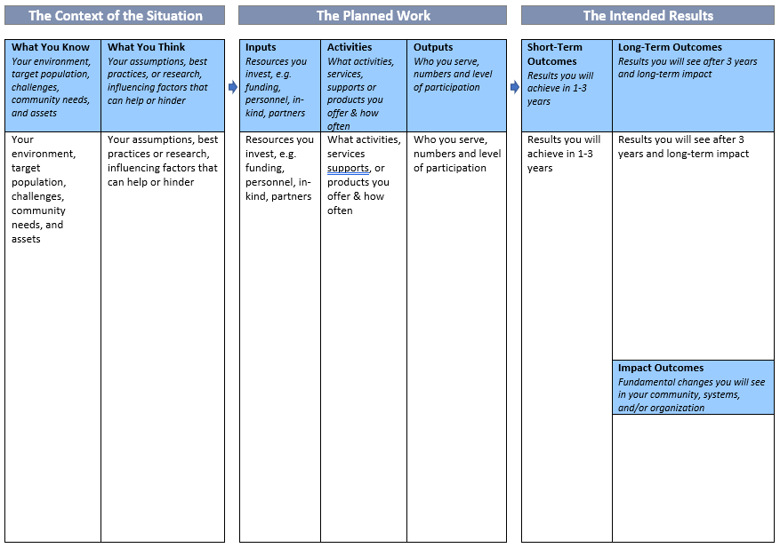

Logic Model Sample
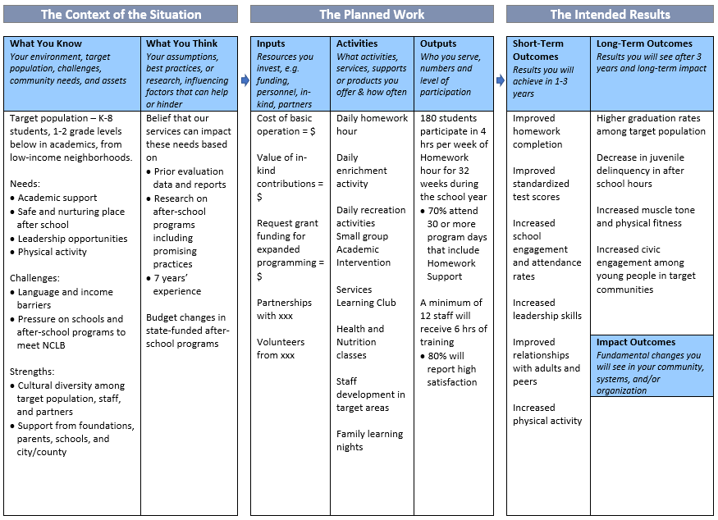

Action Plan
Completing and Using Your Logic Model

Who else should be involved in developing your Logic Model? Think about your stakeholders, i.e. staff, Board, participants, partners, community members

When will you work on the Logic Model? When do you want to have the Logic Model completed? Do you need to set specific meetings? When and where will you meet?

How will you use your Logic Model? Think about the main purposes of logic models,
i.e. create common language among stakeholders (who are they?), articulate your vision and theory of change, strengthen your program design, clarify your outputs v. outcomes, identify evaluation points, communicate with funders, marketing and outreach to participants, families, partners, etc.

Purpose | Stakeholder(s) | Timeframe

© 2009 Hatchuel Tabernik & Associate

