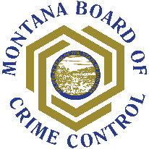

MBCC Subrecipient Single Audit Certification Form

Effective with fiscal years beginning on or after December 26, 2014, the Uniform Guidance requires all recipients of federal funds to have a single audit conducted when total federal award expenditures are $750,000 or more during a fiscal year (Subpart F – Audit Requirements). This threshold includes federal award expenditures from all sources, not just from MBCC. For this reason, this certification form should be completed by a financial official in your organization who has access to grant records for your entire organization. Your assistance is needed in completing and returning this form to MBCC. Please upload the completed form to the documents section in each of your projects and send the original back with your signed grant award.

Agency |  | UEI Number

Did your organization expend $750,000 or more in total Federal awards your immediately preceding fiscal year?
(expected completion date)

☐ YES A Single Audit is Required.

If the answer is YES above, your organization must submit a copy of your Single Audit reporting package to the Federal Audit Clearinghouse (FAC) within the earlier of 30 calendar days after receipt of your auditor’s report(s), or nine (9) months after the audit period. In addition, if the audit disclosed findings that relate to any award(s) provided by MBCC, your organization must concurrently submit the audit report package to MBCC, along with a list of related findings and a corrective action plan, to address those findings.

☐ NO A Single Audit is NOT Required.

I certify that, to the best of my knowledge, the above information is correct:

Financial Officer Signature |  | Title

Date |  | Email Address

